**Writing Portfolio**

**[Name]**

W6A

Summer Writing Course

With Mr. J at Teachall

July-August 2020, Beijing

**Index**

**I**

**Essays**

1. Essay 1: My Crazy Day

2. Essay 2: Making a Claim About a Historical Event

3. Essay 3: Using Variety When Introducing Narrator’s Thoughts

(Picture: Story Arc)

4. Essay 4: Narrative Writing Exercise

(Picture: Story Arc)

5. Essay 5: Writing from the Point of View of a Fictional Character

(Picture: Story Arc)

6. Essay 6: Analyzing Literature: Noticing the Author’s Choices in “How the Leopard Got His Spots” by Rudyard Kipling

(Picture: Story Arc)

7. Essay 7: Narrative Worksheet: Short Story

8. Essay 8: Letter to Captain

**II**

**Journal Entries**

1. Do you enjoy writing? Why or why not?

2. What is the one thing that you want to change about yourself?

3. What unexpected thing happened to you recently? Why?

4. What are three reasons why the global pandemic is good?

5. Write a 200-300 word summary of the article using at least three direct quotes.

6. Write your opinion of the situation. Do you agree or disagree with the writer? Why?

7. What character traits are most important to you? Why?

8. Why do some people struggle to do the right thing?

9. What does it mean to have integrity?

10. What is the hardest lesson you’ve ever had to learn? Why?

11. What is your favorite way to show your individuality? Why?

12. If you could take home any animal from the zoo as a pet, which would you choose?

13. What is your favorite way to show your individuality?

14. Who is your hero? What inspires you about this person?

**I**

**Essays**

[Essay 1: My Crazy Day: Draft 1]

Last year June when I still having daily class in Rising Eagle, our school had conduct a one night stay field trip on a mountain in Tianjin. That place was in a forest on the top of the mountain, so there have fresh air and full of nature, but also that place was very hot. Because I used to live in Taiwan so I could accept that kind of weather.

We gathered at the school gate at nine o'clock that morning. When everybody all present, teacher instruct us to the bus that we should ride. We were in that bus for over three hours to get in Tianjin. After arrived, we climbed another slope with our luggage, everybody began to sweat because of the weather. The top of the mountain is full of plants and fresh air. And we suddenly found out that there were a lot of exciting and fun facilities there, like bungee jumping and high ropewalking. Luckily I'm not afraid of heights at all, because everything at there was so high! And I love it, I love the view on it! When I step on the top of the facility, I can totally felt the wind blowing, and fresh air surround me. The bee was buzzing beside me, and the cloud was so white, I never saw that kind of cloud. For a moment I believed that if I could, I'd have to do it again. Then when the sun was setting, my class teacher organize our volleyball match. Because we both suck, so we never win each other that day, but we still got a lot of fun in that match.

It was already seven o'clock after dinner, the teacher told us to gather in the hall we will had a bonfire party at nine o'clock, in the between we could take a bath. After we all took bath, be gather in the hall, everybody is excited and we had brought some marshmallows. It was nine a half o'clock when everyone arrived. It will take about fifteen minutes from where we stay to where we can make a fire; and because it was too dark so I couldn’t even saw who was beside me, it’s sort of dangerous for third and fourth grade. When we arrived to the place that we ready for bonfire party, everybody was waiting for teacher to fire up the wood bricks. Our job that day is to put marshmallows on sticks. After we do all the work, my hand smell just like marshmallow. When every prepare work done, we began to sang, and we bake our own marshmallow. That was the first time I’ve ever ate the marshmallow had been baked. Teacher begin to talk about the fun story about themselves and we had laugh all night.

We finish the party at eleven o’clock, no one want to leave but it was too late. We talked about what just happened all the way back to the dorm. The way went back was so dark, I felt like we’re having adventure, and there’s full of stone on the way, so we all walk carefully. The night spend there was peaceful, and we all have a great night.

Next morning was quickly, we packed our luggage and leave at ten o’clock. The bus was noisy, somebody was excited, and somebody fell asleep. I was excited and talk to my friend about the facility yesterday we had and the bonfire party. After we arrive to our school, we had a movie with our lunch, and we go home at 3 p.m.

That day is my favorite field trip, all my classmate felt wonderful and want to have it again, and so do I. I really love height, because when I stand at a high place, I would fill the wind and I could overlook at all the things down there, like city, forest, and ocean. I could spend all day on the mountain. So that’s why I feel that field trip was my craziest day in my life.

[Essay 1: My Crazy Day: Draft 2]

Last June when I stilled having daily class in Rising Eagle, our school conducted a one night field trip on a mountain in Tianjin. That place was in a forest on top of the mountain, so there had fresh air and full of natural phenomenon, but also that place was very hot. Because I used to live in Taiwan I could accept that kind of weather.

We gathered at the school gate at 9 a.m. that morning. When everybody was present, teacher instructed us to the bus that we should rode. We took more than three hours in that bus to Tianjin. Upon arrived, we climbed another slope with our luggage. Everybody began to sweat because of the weather. The top of the mountain was full of plants and fresh air. Suddenly we found out that there were a lot of exciting and fun facilities there, like bungee jumping and high rope walking. Fortunately, I did not afraid of high at all because everything there is high! And I loved it, I liked the view above. When I stepped on the top of the facility, I can totally felt the wind blowing, and fresh air surround me. The bees were buzzing around me, the clouds were so white that I had never was that kind of clouds. For a moment I believed that if I could, I'd have to do it again. Then when the sun was setting, my class teacher organized our volleyball match. Because both side of the team suck, So we never beat each other that day, but we still get a lot of fun in that match.

It was already 7 p.m. after dinner, the teacher told us to gather in the hall at 9 p.m., we will had a bonfire party at outside; in between we could take a bath. We all gathered in the hall after the shower, everybody was excited and we had brought some marshmallows. It was 9:30 p.m. when everyone arrived. It took about 15 minutes from where we stayed to where we could make a fire; and because it was so dark that I couldn't even see who was beside me. When we got to the place where the bonfire party was, everybody was waiting for teacher to fire up the wood bricks. Our job that day was put marshmallows on sticks. After we done all the work, my hand smelled just exactly like marshmallow. When all the preparing work had done, we began to sing our school song, and we baked our own marshmallows. It was the first time I had a baked marshmallow. Teacher began to talk fun stories about themselves. One of my teacher said,” When I was young, I've never had cotton candy, I did not have cell phone or any electronic product, and I'm writing letters if I want to talk to my family far away. You guys are so lucky and happy can born in this age. When I was young, every day after I finished my school, I have to go back home immediately to took care of my parent’s store. People in my generation don’t have rich families to give their children expensive clothes and shoes, we only ate lollipop and jelly when somebody came to visit my home. We don’t have video games, we only have caricature and TV play.” This kind of thing I’m sure that many children had heard it thousand times; Something like you’re happier than I was, or I was more obedient than you when I was a kid. I know that I born in this generation. There are many temptations in this age, like video games, cartoon, more and more movies. This generation has a lot of temptation than last generation, but I think my teacher’s point is let us wake up, run away from the temptation. We finish the party at 11 p.m., no one wanted to leave but it was too late. We talked about what just happened all the way back to the dorm. The way back is too dark, I think we are taking adventures, the road is full of stones, so we all walked carefully. The night spent there was peaceful, and we all have a great night.

The next morning came very quickly. We packed up and left at ten. The bus was noisy, somebody was excited, and somebody fell asleep. I was excited and talked to my friend about the facility and the bonfire party we had yesterday. After we arrive to our school, we had a movie with our lunch, and we go home at 3 p.m.

That day is my favorite field trip, my classmates all felt wonderful and wanted to have it again, and so do I. I really love heights, because when I stand on the high place; I could feel the wind and overlook all the things down there, like city, forest, and ocean. I could spend all day on the mountain. So that’s why I feel that field trip was the craziest day in my life.

[Essay 2: Making a Claim About a Historical Event: Draft 1]

What will happened if America and other countries stand out when Germany just began coerce and tyrannize the Jewish. A Holocaust in English and German is called "Holocaust", this word is from Greek, meaning burning sacrifices with fire. Jews called it "Shoah", from Hebrew, with the meaning of" holocaust.” The Holocaust refers to the ethnic cleansing of Nazi Germany in World War II and is one of the most notorious atrocities in World War II. Germany massacred nearly six million Jews during the ethnic cleansing.

After Nazi Germany's lightning-fast occupation of Poland, Denmark, Norway, the Netherlands, Belgium, Luxembourg and France into their own possession, and the Jews in those countries naturally lived under fascist’s control. German Defense Forces, Nazi Germany and German Government all concerted action to persecute Jewish. Then Nazi even started incitement to the public to oppose to the Jewish. The Jewish has no freedom, they have to wear Jewish star. Everybody will have the eyes of despise to them when they walking on the street. Jewish force to live in Jewish district. Because that place is too small and no one get out, so there was an infection began to spread. Every Jewish that walking near around the export could being shot by the soldiers. A large number of children were sent to concentration camps in batches. Children over the age of 14 were treated as adults in the process of being sent to concentration camps. Sometimes the innocent, weak children came home from a children's home in a school or a Jewish neighborhood and saw only unfamiliar faces at home, and their parents had been poisoned. January 27, 1945, the Soviet Red Army invaded Auschwitz concentration camp, they saw 7650 ghost-like people —— Holocaust survivors. The Soviet Red Army, which liberated Auschwitz, was the 100th Infantry Division and the 107th Division 504th Infantry Regiment. On the way to the liberation of the concentration camp, the Red Army of the Soviet Union exchanged fire along the road and the fleeing Germans. There were 231 Red Army soldiers sleeping in the battle to liberate Auschwitz.

-https://baike.baidu.com/item/犹太人大屠杀/4816832

Last paragraph is a brief summary of the Holocaust. Jewish were suffered in the Holocaust, no body care about them. Even though the Germans made a lot of excuses for this things, but that doesn't wipe out what they did. In my opinion, everybody in the Europe didn’t like Jewish that much. The reason of this I think is because Jewish were smart and rich, they were having business in Europe, and Because when the Germans were hungry for milk and couldn't afford it, Jews would rather dump it than sell it at a lower price. Another reason I think is that most of the country in that time was Christian, and Judas who was Jewish sell Jesus who was God’s child to another Jewish judge for death, so people hate Judas and hate Jewish because they think they were arrogant and for the sake of profit.

What will happen if American soldiers and Soviet Red Army came before fascist killed so many Jewish? Will Jewish grow stronger than now? In my opinion, if Germany didn’t coerce Jewish, I think Germany's defeat will be delayed; because there is no money to wage war, to delay the beginning and to put an end to it. The massacre intensified the conflict and accelerated the end of the war. I couldn’t say that Germany’s defeat will be delayed is a good thing or not, but in any point of view disservice others is not a good action, and you can’t erase what happened. There’s a lot of movies talking about this thing, mostly are specifically talking one family or one man, children; like, La Vita è bella, The Boy in the Striped Pajamas. I think they make movies is to remember those who sacrificed and suffered for this Holocaust. The most terrible thing that happens in the world is not the people killed by the virus, it is always the people who kill each other.

[Essay 2: Making a Claim About a Historical Event: Draft 2]

What would have happened if America and other countries had stood up when Germany just begin to oppress the Jews? “’Holocaust,’ this word is from Greek, meaning burning sacrifices with fire. Jews called it ‘Shoah,’ from Hebrew. The Holocaust refers to the ethnic cleansing of Jews by Nazi Germany in World War II and is one of the most notorious atrocities of the war. Germany massacred nearly sixth million Jewish people during the ethnic cleansing,” according to the article publish on Baidubaike.

“After Nazi Germany's lightning-fast occupation of many countries, and the Jewish in those countries naturally lived under fascist’s control. The German Defense Forces, Nazi Germany and German Government all concerted action to persecute Jewish people. Then Nazis even started incitement to the public to oppose to the Jews,” according to the article publish on Baidubaike.

The Jewish had no freedom, they had to wear the Jewish star. Everybody would despitefully glare at them when they walked on the street. Jews were forced to live in the Jewish district. Because that place was too small and no one could get out, so there was an infection that began to spread. Every Jews that walk around near the export could being shot by the soldiers.

“A large number of children were sent to concentration camps in batches. Children over the age of 14 were treated as adults in the process of being sent to concentration camps. January 27, 1945, the Soviet Red Army invaded Auschwitz concentration camp, they saw 7650 weak people —— Holocaust survivors. On the way to the liberation of the concentration camp, the Red Army of the Soviet Union exchanged fire along the road and the fleeing Germans. There were 231 Red Army soldiers had dead in the battle to liberate Auschwitz,” according to the article publish on Baidubaike.

The last paragraph is a brief summary of the Holocaust, - Jews were suffered during the Holocaust, and nobody cared about them. Even though the Germans made a lot of excuses for this things, but that doesn't wipe out what they did. In my opinion, everybody in the Europe didn’t like Jewish that much. The reason of this I think is because Jewish were smart and rich, they were having business in Europe; and when the Germans were hungry for milk and couldn't afford it, Jews would rather dump it than sell it at a lower price. Another reason is that most of the European countries at that time were Christians, and Judas sold Jesus, the child of God, to another Jewish judge, because they thought Judas was arrogant and for profit, so people hated Judas and hated Jews. These reason was what they had told us, but it sounds like an excuse to cover up their bullying.

What would happen if American soldiers and Soviet Red Army came before fascist killed so many Jews? Would Jews grow stronger than now? In my opinion, if Germany didn’t oppress Jews, I think Germany's defeat would be delayed; because there is no money to start the war, the war will be postponed. The massacre intensified the conflict and accelerated the end of the war. I cannot say that Germany’s defeat would be delayed is a good thing or not, but in any point of view disservice others are not a good action, and you can’t erase what happened. There’s a lot of movies talked about this thing, mostly are specifically talking one family or one man, children; like, La Vita è bella, The Boy in the Striped Pajamas. I think they made these movies to make people remember those who died and suffered for this massacre. The worst thing that has happened in the world is not virus killing, but human killing. Now still a lot of people have racial discrimination, and they think they are honorable. Not just Jews, both black and yellow color of people had being bullied; but people of different races have different merit, like most of the Jews are very smart and very good at manage money matters, most of the black people have strong strength, most of the Asian country have long history and nice craft; everybody is same value, it depends on you work hard or not. People have to get rid this idea of racial discrimination.

Information resources: -https://baike.baidu.com/item/犹太人大屠杀/4816832

[Essay 3: Using Variety When Introducing Narrator’s Thoughts: Draft 1]

“You can do it! Come on,” my friend was totally screaming. I stepped on the rope and I used my whole body strength to grab the safety rope, I tried to think straight, but I just can't help myself from looking at the floor that is forty five meters away from me. I told myself that walking on this rope is totally safety, because I have safety rope that could grab me from falling down, but I was too busy to wondering about this confusing positive sentence. It’s was totally shame on me, because I never afraid about height, but my whole body was shaking and I don’t even know that I wasn’t moving slowly to the resting area in the middle of this facility. Every step I had move was like hours to me, and I imperceptibly caught breath quickly. The weather was hot, but my whole body sweat because of fear. My safety rope and the rope I was stepped on was both shaking. My mood was chaotic, every part of me was nervous. I was shouting in my mind, but I could never see that kind of view if I didn’t step on that rope.” Michelle! What are you doing? Go on,” my classmate who was behind me was nervous too! He was totally afraid of height. I think if he wait one more second he would definitely cry, so I quickly walked on next part. Next part was even worst, the shape of the rope was like a DNA, and it has short plank on each side of the rope! When I thought I was ready to put my feet on it, I was fool. The rope didn’t shake the way same as straight normal rope! The whole” DNA” thing was totally turn over when I step on it, that’s mean I was nearly turn over and falling down. But didn't lose all my blood because my quick reflex made me catch the safety cord. I promise I must spend twenty minuet on this four meters DNA rope, but I suddenly be clear, I know I could do this, because I never afraid of height, and why should afraid of it now? I stilled grabbing safety rope, but I walked faster; and quickly I found the secret of success! One foot one brick, and slowly move to next one. “Jesus Christ, aaaaaaaaaaa,” one of my classmate had scream although he fell down and the rope catch him, but that was still hurt. Everybody who haven’t walk on this rope was laughing, and I’m pretty sure they won’t laugh after they actually step on the rope! I quick went to another resting area, and the instructor change my safety rope to another steel wire to keep us safe. After a lot of difficulties, I finally reach the end and my whole body was sored. I can’t suppress the joy in my heart, and I never see any view like that anymore.

[Essay 3: Using Variety When Introducing Narrator’s Thoughts: Draft 2]

Walk on the rope

“You can do it! Come on,” my friend was totally screaming in afternoon of a sunny day.

I stepped on the rope beneath my feet and used my whole body strength to grab the safety rope. I tried to think straight, but I just couldn’t help myself from looking at the ground that was 45 meters below me. I told myself that walking on this rope is totally safe because I have a safety rope that could catch me from falling down, but I was too busy wondering about this confusing positive sentence. It felt totally ashamed because I’d never been afraid of heights before, but my whole body was shaking. I didn’t even know that I was moving slowly to the rest area in the middle of the challenge course.

Every step I took move was like hours to me, and I imperceptibly caught my breath quickly. The weather was hot, but my whole body was sweating because of fear. My safety rope and the rope I was stepping on were both shaking. My mood was chaotic, every part of me was nervous. I was shouting in my mind, but I would never have seen that kind of view if I didn’t step on the rope.

“Michelle! What are you doing? Go on,” my classmate who was behind me yelled. He was nervous too! He was totally afraid of heights.

I think if he waited one more second he would definitely cry, so I quickly walked on to the next part.

The next part was even worst, the shape of the rope was like a strand of DNA, and it had short plank on each side of the rope! When I thought I was ready to put my feet on it, I was fool. The rope didn’t shake the same way as normal straight rope! The whole DNA-shaped thing totally turned over when I stepped on it, which meant I nearly turned over and fell down. But didn't lose all my blood because my quick reflex made me catch the safety cord. I promise I must have spent 20 minutes on this 4-meter strand of DNA rope, but I suddenly I was clear headed and I knew I could do this, because I was never afraid of heights, so why should I be afraid now? I still grabbed the safety rope, but I walked more quickly; and soon I found the secret of success! One foot, one brick, then slowly move to the next one.

“Ahhhhhhhh! Help!” one of my classmates screamed as he fell down from the rope. The rope caught him, but that still hurt.

Everybody who wasn’t walking on this rope was laughing, but I’m pretty sure they wouldn’t laugh if they actually stepped on the rope, too! I quickly went to another rest area. The instructor changed my safety rope for another steel wire to keep me safe.

After a lot of difficulties, I finally reached the end and my whole body was sore. This “adventure” in Tianjin was a challenge to me, but not anymore. I become fearless, and also more confident, I never afraid of height again! I couldn’t suppress the joy in my heart. I never want to see any view like that again.

[Story Arc: Essay 3: Using Variety When Introducing Narrator’s Thoughts]

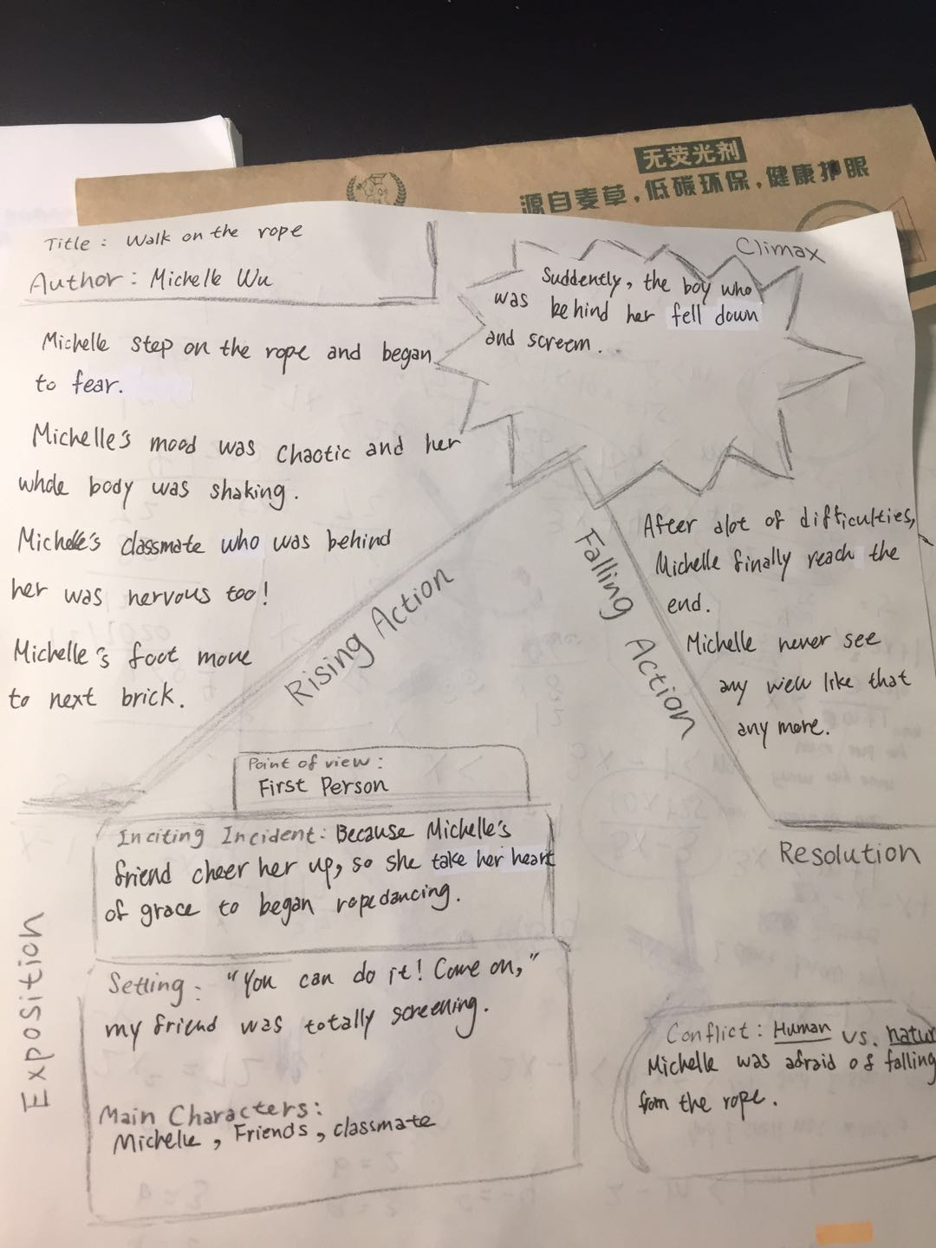

[Essay 4: Narrative Writing Exercise: Draft 1]

That day was hot, everybody was sweating, and we have to show our ID to get in, but my classmate Isabella forgot to bring her ID. We were impatient of waiting.

Last month I went to South Luogu Lane with two other my best friends Grace, Candy and one of my classmate, Isabella. South Luogu Lane is a Chinese old lane, where sell different kind of tasty food, and funny things. We come out together is because my classmate was too boring at home so she want to come out have fun with us; but that day we have trouble to get in.

“Hi! I’m here! Come,” I shouted to her.

Isabella's home is very close to mine, so she invited me out to play, but I thought only two people are very boring, so I suggest that she invite my friends to come with us. We quickly make decision were we should go, and two other my friend were agree too. Because my friends had class in the morning until 12:00 that day, so we made an appointment at Candy house at 2 pm first, but they told me that their teacher had class early at 11:00 in the morning, so we quickly changed the time of that day and we changed the time to 12:30 in the afternoon. Isabella's home and my home are close to the same subway station. The subway station next to Candy home is the next stop of the subway station near us; so I made an agreement with Isabella that we should meet on the subway near my house at 12:15 that day. Because we change time quick that day, so we didn’t notice that Isabella didn’t check her phone, so she didn’t see that we change our time, so actually me and Isabella we didn’t have a deal, because she didn’t know about these things we had change.

At 12:00p.m., I quickly ran to the subway station, when I arrived it was exactly 12:15 p.m.; but she didn’t show up, so I called her, but she didn’t answer. I called her at least four time, but she didn’t answer. After twenty minutes, she called me,

“Michelle! I’m so sorry, I just saw you guys change the time, but I was eating lunch, please wait for me! I’ll be quickly,” she cried.

“Okay! I’ll wait for you! Please be quickly,” I quickly whisper to her.

After fifteen minuet she called me again,

“I’m here! Where are you,” she asked,

“Hi! I’m her! Come,” I shouted to her.

She finally came, but I wait her at least half hours, and Candy, Grace also waiting for her too.

We quickly arrived the subway station beside candy’s house and met them; and we also used one hour to get South Luogu Lane. After we arrived, we found out we need to have ID for get in. Me and my two friend all got ID, but Isabella didn’t, so she called her mom, asked her to send the picture of ID to her.

The day was hot, everybody was sweating, and we have to show our ID to get in, but my classmate Isabella forgot to bring her ID. We were impatient of waiting. Everybody is waiting for her. The cloud moved slowly, because there was no wind. Every people who sale fans came to bothering us. The cicadas on the trees are buzzing, pedlar were yelling. We all feel thirsty, but we still can’t get in.

Finally, her mom send her Isabella’s ID picture. We show our ID and favorably get in.

[Essay 4: Narrative Writing Exercise: Draft 2]

Last month I went to South Luogu Lane with two of my best friends, Grace and Candy, as well one of my classmates, Isabella. South Luogu Lane is an old Chinese lane, where you can buy all different kinds of tasty food; and funny things. Isabella and I hung out together because she was too bored at home, so she wanted to go outside and have some fun. But that day we got into trouble.

Isabella's house is close to my house, so she invited me out to play, but I thought it was boring with just the two of us, so I suggested that she invite my friends to come with us. We quickly made decision were we should go, and my two other friends were agree too. My friends had class from the morning until 12:00 that day, so first we made an appointment at Candy’s house at 2 p.m. But they told me that their teacher had class early at 11:00 in the morning, so we quickly changed the time to 12:30 in the afternoon. Isabella's home and my home are close to the same subway station. The subway station next to Candy’s home is the next stop of the subway line near us. So I made an agreement with Isabella that we should meet at the subway station near my house at 12:15 p.m. Because we changed time quickly that day, we didn’t notice that Isabella didn’t check her phone and didn’t see that we changed our time. So actually Isabella and I we didn’t have a deal, because she didn’t know about our changes.

At 12:00p.m., I quickly ran to the subway station. When I arrived it was exactly 12:15 p.m.; but Isabella didn’t show up. So I called her, but she didn’t answer. I called her at least four times, but she didn’t answer. After 20 minutes, she called me.

“Michelle,” she said. “I’m so sorry. I just saw you guys changed the time. But I was eating lunch. Please wait for me! I’ll be there quickly.”

“Okay! I’ll wait for you!” I quickly whispered to her.” Please be fast!”

After 15 minuet she called me again,

“I’m here! Where are you?” she asked,

“Hi! I’m her! Come,” I shouted to her.

She finally came, but I had waited for her at least half an hour, Candy and Grace were also waiting for her too.

We quickly arrived the subway station beside Candy’s house and met them. We also used one hour to get South Luogu Lane. After we arrived, we found out we need to have IDs to get in. My two friends and I all had our IDs, but Isabella didn’t have hers, so she called her mom and asked her to send her a picture of her ID.

The day was hot, everybody was sweating, and we had to show our IDs to get in. But my classmate Isabella forgot to bring her ID. We were impatient of waiting. Everybody was waiting for her. The clouds moved slowly because there was no wind. Every person who sells fans came to bother us. The cicadas on the trees were buzzing, peddler were yelling. We all feel thirsty, but we still couldn’t get in.

Finally, her mom sent her a picture of her ID. We all showed our IDs and finally got in.

There are so many tasty snack there, like freshly grilled sauced squid, Ice cream with cold cream flavor on freshly fried rolled waffles. The scent can be smelled from a distance. I've never eaten such delicious waffles and ice cream, I love how they put foods together and made a tasty snack. The ice cream on this side is pretty creamy and the freshly fried waffles are pretty golden color. I was so hungry, so every food was so attractive to me. We began to shopping excitedly! First, we ate grilled squid, soy sauce sprinkle on the squid. The smell of the squid was totally smell like home, because Taiwan has the best seafood I had ever ate! I love how they cook the squid, it just made the squid’s color so tasty and smell so good! Second, we ate ice cream that’s in the waffles! Ice cream is perfect for hot waffles. The ice cream taste really creamy and also smell like milk! The waffles was very hot because it just being fried! So this snack just tasted hot and cold! The last snack we had ate was jasmine bay salt green tea. That is the best drink I had ever drank! There are caramel in the bottom of the drink, then is Japanese green tea in the middle of the bottle, then we have fresh cream on the top of the drink! It sounds full of calories! I love South Luogu Lane, there has so many food!!!

After we done our shopping, we are totally full! We finished our snacks and went home with grateful heart. We have enjoyed our friendship and also have a great time! [Story Arc: Essay 4: Narrative Writing Exercise]

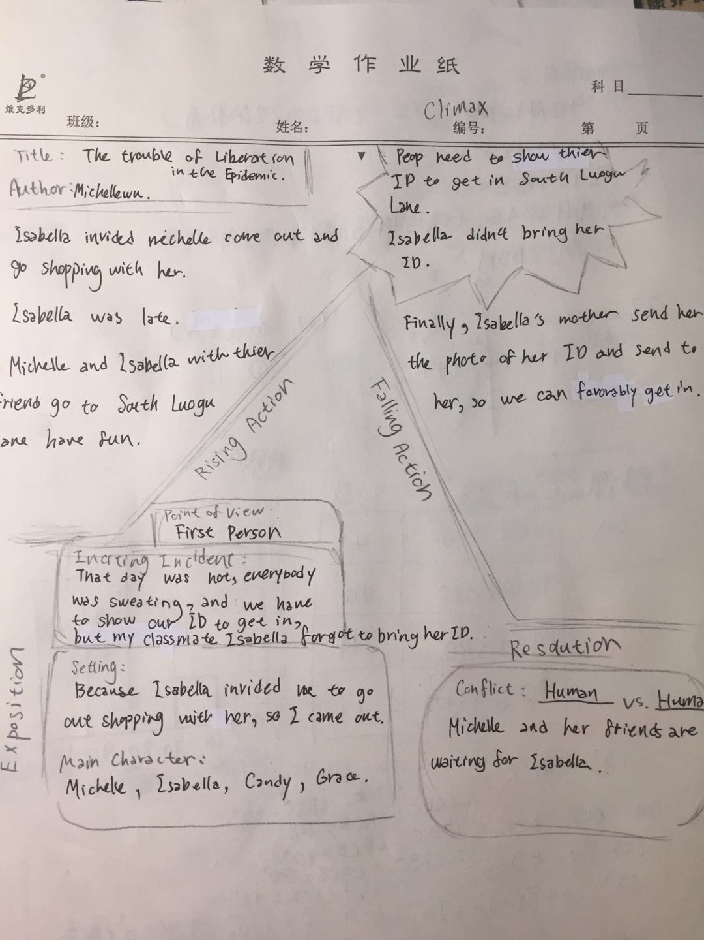

[Essay 5: Writing from the Point of View of a Fictional Character: Draft 1]

When I was young, I lived in a poor village in 234 BC. Our village is cold all season, with no water; if we need water, we have to walk one kilometer to get to a well. One day in a peace normal morning, we heard the horseshoe from a distance. That day was the worst day of my life, blood splashes, women and children screaming. I run away and hide in a cave beside the village, I had stayed in there for three day with a bottle of water and a magical mirror that tells truth, and then I never see my parent since that day. I had lived in a forest for several years, I find a place that close to the river, so I don’t need to worry about no water. When I was 20 years old, I was founded by a King of England, he founded me and married him to be his wife. He had a beautiful daughter called snow white. She had beautiful white skin and skinny body with a lot of beautiful dresses. I like her, she was so kind and nice. But one day when I picked strawberries till night, there was many arrows struck me. I was afraid and worried, I ran away and quickly. I feel I might die at there, I was screaming and running. I have no time to breathe and cry. I was weary and my clothes was break in to piece. When I get back home, I took out my magical mirror,

“Who was trying to kill me? Why,” I asked tensely.

“It’s Snow white, she hate you that you replaced her mother, and she hate you because you are so beautiful,” the mirror answered with no feeling.

“I love her and she was so beautiful! Why she did this kind of thing,” I cried.

“She didn’t show her evil side to people,” mirror whisper,” She is behind your door!”

I don’t know that Snow white just stand behind the door before, she knew she was exposed. She quickly hired a hunter to pretend that I was going to kill her. She run in the woods and tempt seven dwarf to take in and bring up her. I was worried about her, she was so young she couldn’t just left. So I dress up like an old ugly woman that sell apples so she won’t know that I’m her stepmother, this thing is my problem, I didn’t knew that the apples are already has been moulded. She was sick and fainted, I worried about her, but I cannot be expose, so I ran away. Then, you know, prince came, and saved her, she found her love, but I was maltreat by her when she found out the “truth.” I dead, well it’s good to have this kind of life that have so much interesting character, right? Life like this, it happened all the time.

[Essay 5: Writing from the Point of View of a Fictional Character: Draft 2]

When I was young, I lived in a poor village in 234 BC. Our village is cold all season, with no water. If we need water, we have to walk one kilometer to get to a well. One day in a peace normal morning, we heard the horseshoe from a distance. That day was the worst day of my life, blood splashes, women and children screaming. I run away and hide in a cave beside the village, I had stayed in there for three day with a bottle of water and a magical mirror that tells truth, and then I never see my parent since that day.

I had lived in a forest for several years, I find a place that close to the river, so I don’t need to worry about no water. When I was 20 years old, I was founded by a King of England, he founded me and I married him to be his wife. He had a beautiful daughter called snow white. She had beautiful white skin and skinny body with a lot of beautiful dresses. I like her, she was so kind and nice to me.

One day in the middle of the night, I can’t sleep. I walked out and trying to find the path of palace to garden. I hold my delicate antique handed lamp and airily walked on the flagstone. I heard owls were purr and the noise of wind slashing the old tung tree. I was humming along the brisk pace and felt excited.

Suddenly, there was a noise that was groaning, I didn’t notice. I still walked through the byway and I still in a cheerful mood. In a second, a sharp classical arrow came at me, and although I was not shot, but it still scratched my cheek. I was scared, but I know that I can’t stay here anymore. I put out the light and quickly ran in to the garden that I was going to. I crept quietly into the nearby bushes and held my breath for fear that I would fall to death. I heard foot step near around me, it was heavy and careful step. I seated there for ten minuet, then I heard the foot step walked away. I carefully walked out. Suddenly,

“Stop,” a voice in the dark cried, even though I don’t know who she is, but I know she is a girl and her bow and arrow were pointing at me.

“Who are you? Why you’re trying to kill me,” I said angrily to her.

“That’s my question, who are you? Why you’re trying to take away my mother’s place in my dad’s heart? Why are you tempt my father? You didn’t belong here. You didn’t belong here!” She shouted.

“Snow white? What are you doing here? Go back to your bedroom now,” I surpisedly cried.

“What kind of power that let you can make commandment to me?” She is totally angry.

She ran away, and I cannot believe what I just saw and heard. I over thinking did I hurt her spirit? Am I trying to replace of her mother? But none of these thing are true. She just made excuses that make she feel better to hate me with no reason. I couldn’t believe one day I will be the evil step mother.

Then, you know, she ran in to the forest, dwafts found her, prince came, and saved her, she found her love, but I was maltreat by her when she told everyone the “truth” that she made herself, “The evil witch poison her, and she dead, the prince found her;” so I dead. Well it’s good to have this kind of “life” that have so much interesting character, right? Life like this, it happened all the time. Good luck don’t always be with innocent people. Some nice people dead, some evil people lived, this is life.

[Story Arc: Essay 5: Writing from the Point of View of a Fictional Character]

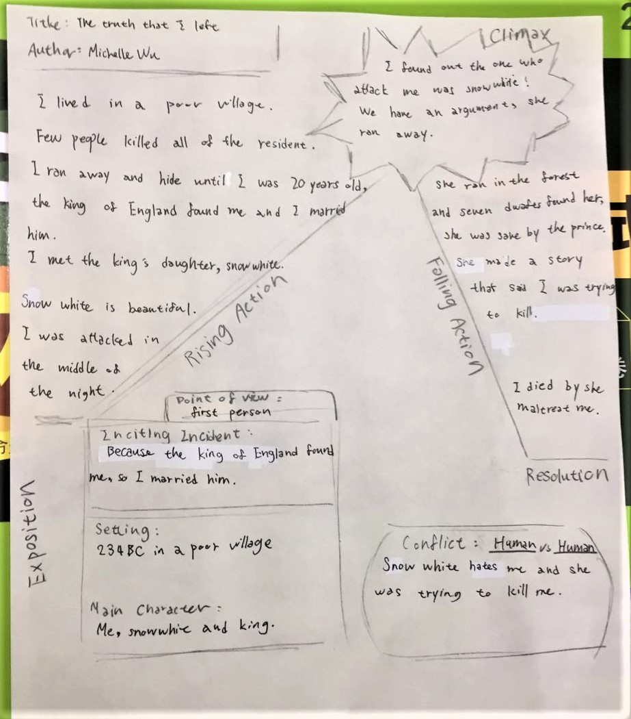

[Essay 6: Analyzing Literature: Noticing the Author’s Choices in “How the Leopard Got His Spots” by Rudyard Kipling: Draft 1]

In the story of “How the Leopard got His spot”, the author, Rudyard Kipling made many choices, such as writing “weird” words, using third person, and using personification, to create a world that is talking about a Leopard who once is full of brown skin that is similar to the color of the stone and land so nobody see him when he is quiet. When Giraffe, Zebra, Eland, Koodo and Hartebeest are having rest or eating food, he and his friend, Ethiopian stand beside them and waiting for a good opportunity to catch them for breakfast. After a long time, Giraffe, Zebra and Eland had enough, they ran in to Great Forest and hide. Giraffe, Zebra, Koodo and Eland change their skin in to spot, stripe, and darker. After Leopard and Ethiopian found out their breakfast run away, they chase them in to the Great Forest, but they couldn’t found them because those animals have many different pattern on their skin same as different kind of plant in the forest. Ethiopian told Leopard he should have the pattern so they could hunt those animal faster. Then he paint Leopard spotty by his hand, and have happily ever after.

Firstly, Rudyard Kipling made the choice of writing” weird” words. His words is not actually weird, but he put them in to funny ways, like

” they were 'sclusively sandy-yellow-brownish all over; but the Leopard, he was the 'sclusivist sandiest-yellowish-brownest of them all a greyish-yellowish catty-shaped kind of beast.”- According to the article publish by China Translation & Publishing Corporation.

He used a lot of different kind of adjective on describing animals, and he used it vividly and amusingly. He had his own writing techniques and his own attitude towards writing. He didn’t write this story with curt boring words, he write this story audaciously, he didn’t think these word would make his story weird, he used it as innovative, and it did!

Then, he choose to use third person. It’s kind of familiar writing techniques, but it’s a good writing techniques on writing. Third person can make things that people want to narrate more clarity, because using “God’s view” can clearly write about what others’ thought and what everyone is doing even they weren’t together. Rudyard Kipling did a great job on this story, He made good use of the benefits of the third person. He let the reader clearly understand every movement of each animals’ action with no doubt.

Lastly, he choose to personification. I think this is the most important part of his story. He used the personification method well without doubt. He let this story became vivid and interesting, he also catch reader’s mind so reader will want to know what happen next. He skillfully used personification to make his story better understood and real. I think he made a good choice on this, because if he didn’t used personification, this story will definitely show up like BBC, not a children’s book.

Rudyard Kipling’s story is totally interesting and full of imaginations. The story of “How the Leopard got His Spot” have none unnecessary word. I think this story is very short and very clear, we could totally understand what the author is trying to tell us. Rudyard Kipling was a wonderful writer, his book is vivid, interesting and also conspicuous. I was totally in to this story.

[Essay 6: Analyzing Literature: Noticing the Author’s Choices in “How the Leopard Got His Spots” by Rudyard Kipling: Draft 2]

[Story Arc: Essay 6: Analyzing Literature: Noticing the Author’s Choices in “How the Leopard Got His Spots” by Rudyard Kipling]

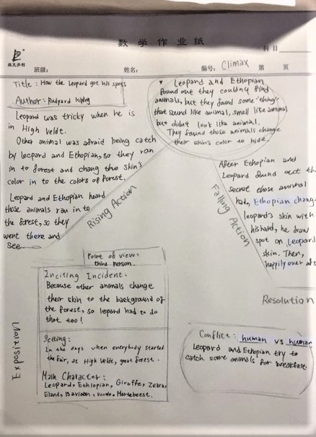

[Essay 7: Narrative Worksheet: Short Story: Draft 1]

**The End of the World**

I lived in 4020s, world only left with ruins; the city I lived in has no survivors but me, Diana and my friend, Leo. World War III began at 4017s, you can imagine who fast this world turning in to dust. People in this world didn’t really” die,” they are like “living corpse,” I called them “the dead.” They are just as same as you might know, bite everything live, and people will turning in to them. Me and Leo, had lived because we had protective clothing that came from my dad’s atelier, we need to wear it every day to protect us from the radiation. In World War III, every country began to shoot N-bomb, I think that is the cause of people turning in to “the dead.”

Leo and I travel to an island on the Atlantic by a map and few bottles of water on a boat, don’t asked me how I get there! When we got the island we found out there are two survivors who was call Andrew and Clara. I don’t know how can they escaped from the radiation by no protective clothing, then they told me the island didn’t get bombed, and it’s far away from USA. They came here to have a vacation, but after the day they arrived, world was destroyed, so they didn’t even know the World War III was end. Then Leo and I stayed there for weeks.

“Clara! Please come help me fix this boat! I couldn’t believe it was broken! Who did that?” I shouted.

“Diana, I think Leo just broke it, but I don’t know why. I think you should go and talked to him,” she whispered to me.

I quickly ran to the jacal beside the beach,

“Leo! Why did you brake the boat, we might use it,” I cried.

“Where could we go? We need woods to have fire, you know what I’m talking!”

“But what if anything goes wrong here? We need boats!”

Suddenly, land began to shake, I hold the wall tightly.

“Ahhhhhhhh! Help!”

A voice quickly came there, it’s Clara!

“Clara! Wait for me! I’m coming,” I screamed to her.

I quickly grabbed Leo’s hand and we support each other to keep each other from falling down.

“Clara! Grab my hand! Quickly,” I shouted.

Clara quickly jumped out of the broken boat and throw away the tools on her hand, she grabbed me!

“I knew it! My father once told me there are a big volcano in the Atlantic, and it is an active volcano. I think we are standing right up on it,” she cried.

“Clara! Leo! Diana! Where are you guys?”

We heard a voice was shouting, it must be Andrew!

“We’re here! Andrew! We’re here,” Clara cried.

“Let’s go! We need to get out of this island!” I was nervous.

We ran to the beach on other side of island.

“Look! There’s a boat! Let’s go! Quickly,” Leo whispered.

We pushed the boat in to the water, everybody got their own bottle of water and ship’s bread. When they all jump in to the water, the boat flow away.

“Diana! Quick, we’re going to flow away, jump on the boat! Quickly,” Clara shouted to me.

“I’m trying!” I almost cried,

“You guys are too far away from me! Oh no,”

Suddenly, a rope was thrown at me,

“Diana! Quickly grab this rope,” Andrew shouted,

“We have no more time! Quickly!”

I grabbed the rope and the boat stopped flowing, I quickly jumped on the boat and climb in.

“Thank you, Andrew!” I’m finally relieved.

“Bomb!”

A great sound came upon us with a great shock, is the volcano! It exploded! Magma quickly flowed out.

“We could be died now if we slow one second!” Clara laughed.

“Yeah! That was really closed!” Leo and I laughed too.

“Well, thanks God!” Andrew forced smile, he looks exhausting.

We flowed on the ocean for hours, but luckily, the rescue personnel came to search for survivors, and they saw us. That is totally lucky. We being taken to a survivor camp, most of the survivors are same age as us, sixteen to thirteen. Well, the story will end here, I got to wake up five a.m. tomorrow. Goodnight.

[Essay 7: Narrative Worksheet: Short Story: Draft 2]

[Essay 8: Letter to Captain: Draft 1]

I had learn a lot in this course. This class let me remember a lot of rules in writing I had learn before, and it let me understood many important rules we should follow in writing.

The first thing I had learn some rules about writing research paper, like using quotation marks and write down the website about where you get that information. The second thing I also had learn is how to draw an arc before writing a narrative, it could help us to write the story in order. The last thing I had learn is using different kind of adjective, adverb and verb, like using enormous to replace big, using adorable to replace cute. This class really help me doing on writing essay.

I like about this course is because I actually really learned in this class. I also feel excited to be in this class because both teacher and classmates all work hard and they all really in to this class. This class has a good atmosphere and good attitude on everybody. Miss Shannon and Mr. J will answer my question all the time even in the day that we don’t have class, and they really have a lot of patient on me. I’m thankful to these two teacher.

I think maybe in next time teacher can give us feedback quicker, so we could write our draft2 immediately and it doesn't drag the draft2 to the end of the course. I hope teacher could give us the draft2 on time so we won’t have too much works to do at the end of the class. I think I think next time I would try my best to do all the homework faster and clearer. I think I also can be more patient next time. I would still try my best to work on homework and classes.

[Essay 8: Letter to Captain: Draft 2]

**II**

**Journal Entries**

[Journal 1: Do you enjoy writing? Why or why not?: Draft 1]

I do enjoy writing, but it depends on different kind of time. Sometimes when I been through something fun and excited, I want to depict it down in my writing. Sometimes when I was angry to somebody or something I would be willing to write it down to express my indignation. To tell you the truth, if I could choose to do anything I wanted to do, writing wouldn't come first. But generally speaking, I do love writing, and I love how people express their feeling in their writing too.

[Journal 1: Do you enjoy writing? Why or why not?: Draft 2]

[Journal 2: What is the one thing that you want to change about yourself?: Draft 1]

I would love to get rid of the fact that I’m afraid of having lecture in the public. I’m not able both having eye contact to the audience and having loud voice. I always already began sweating before I even step on the stage; But every time when I saw the audience’s face, I will be so nervous. Even thought that I already practice so many time, I still couldn’t get rid of the psychology of fear. I have this trouble for a long time, and I think I could be braver and I will be braver to defeat this kind of psychology.

[Journal 2: What is the one thing that you want to change about yourself?: Draft 2]

[Journal 3: What unexpected thing happened to you recently? Why?: Draft 1]

Everything has come so fast this year, and new events already have begun before I can react. Everyday sunset fade away, but none of these things end. I could say that God is warning us, something is coming, and we could not stop it; But life keep moving on, time would not stop because of these trouble. It is not the world that makes you too disappointed, is you have too much expectation to the world. The thing that unexpectly just happen to me or anybody was the coronavirus.

Coronavirus cause a lot of events happened, most of it was negative. I’m stuck at home for month, and I could not go out. The positive thing that happened was that I have more time together with my family; and second is that I have more time to study myself. The negative things happen was that I could not see my friend and my teacher, I could not breath the fresh air and I got fat. If I compare with the time I used to go to school every day, I will still want to go to school. The difference between homeschool and school is that teacher will point out the key point of what you need to learn if you were in daily school; in homeschool you need to point the key point out yourself, and you need to figure out the thing that you don’t understand yourself.

I think if anything like this epidemic happen again I will still follow the instructions of the Government. Stay at home as much as I can, go out and wear a mask and keep social distance. I think I will do better on my homeschool study, like find the key point quickly and work on the thing I don’t really understand. I think I will do better on cleaning, because I didn’t really wash my hand every day I come home, so that’s a little dangerous; and I didn’t wear mask every second, sometimes I take off because it was really hot.

I think China did a good work to fix the problem, and I think they should to help other countries’ epidemic; because if only few countries have control the virus will not working, only somebody find out and make out the cure successfully, the virus will gone. I hope this epidemic could end as soon as it could be.

[Journal 3: What unexpected thing happened to you recently? Why?: Draft 2]

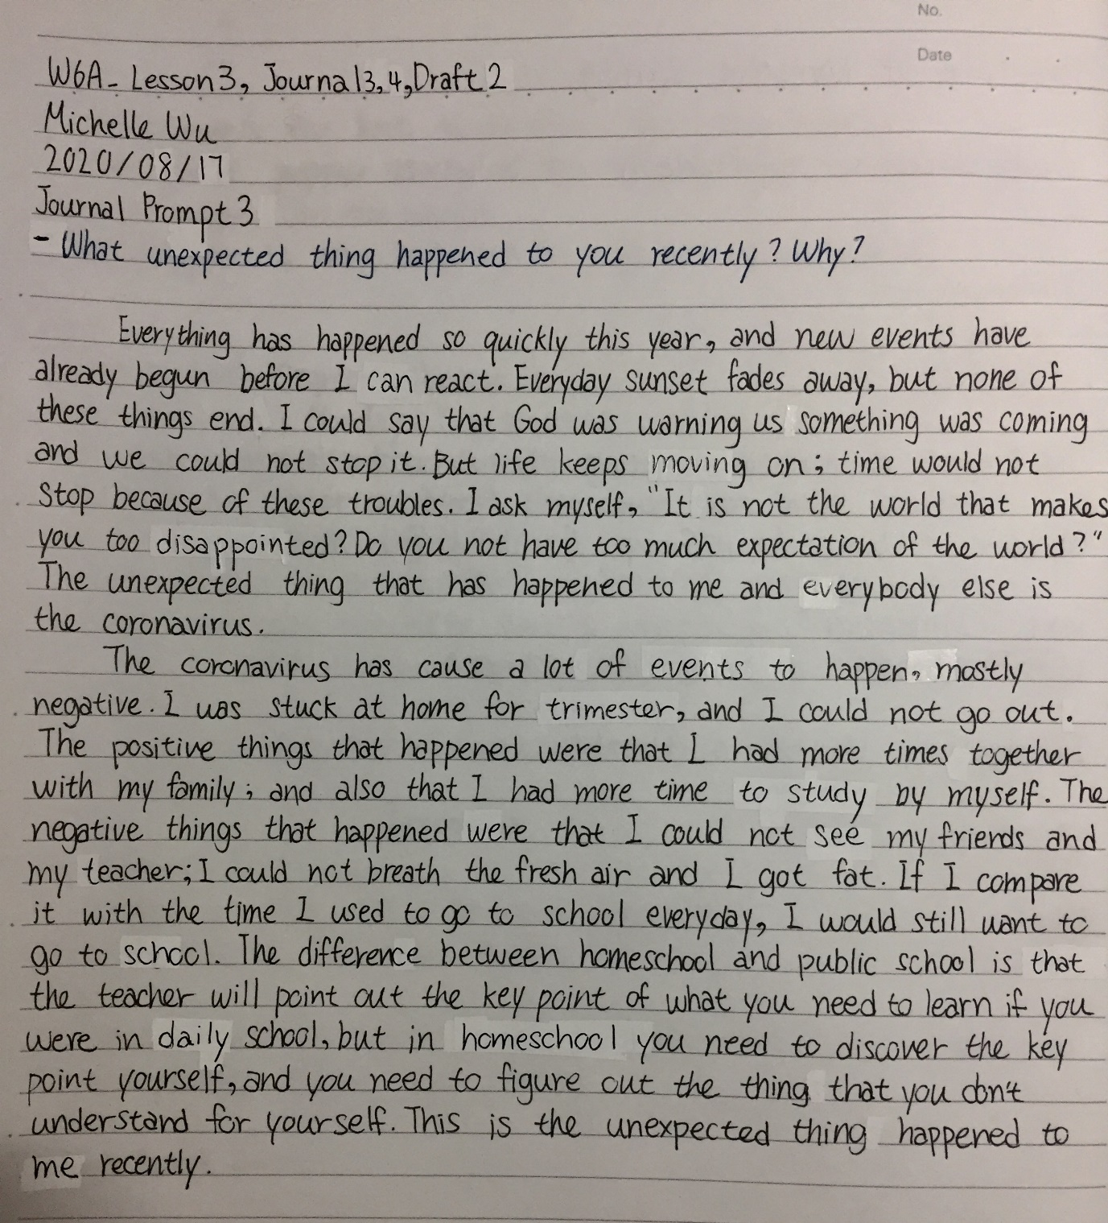

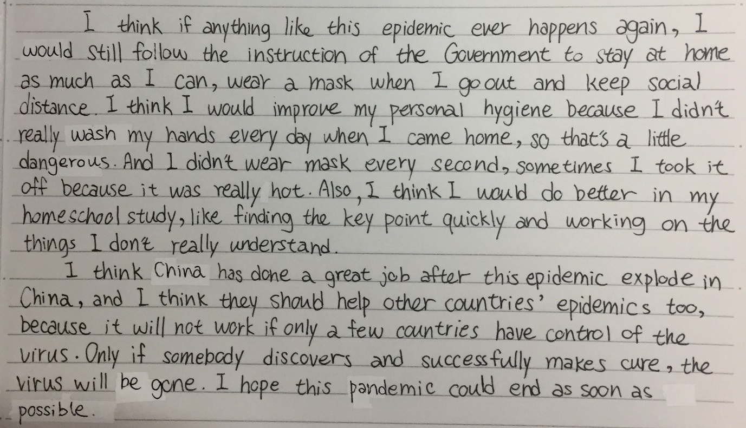

[Journal 4: What are three reasons why the global pandemic is good?: Draft 1]

Covid-19 are the global epidemics we having now. Many people lost their jobs, families, friends, lover cause of this global pandemic. Some people even went to rob stores because they don’t have money for life. Every students were staying at home having online classes, and no one find out the cure or something could end this mess. Everyone thinks the epidemic is only a negative things 0for us, but it's also have some positive things to us, like reorganization, understand clearly, and accompany.

First, Reorganization; People are beginning to discover what their national leader’s personality is. Take the USA, for example. President Trump didn’t really help his people to fix what’s happening. For another example, mayor of New York City, he did a great job after the epidemic explode in New York City. Well, people can always do things to their advantage because God give us chance, but sometimes there are conflicts of interest, it depends on which way you want to choose. Who's going to help people stay away from viruses and germs?

Second, understand clearly; People are beginning to realize that global warming is progressing rapidly, it’s not just a fairy tale. People began to attach importance to environmental protection. Now China have mention that since the end of 2020 Non-degradable disposable plastic straws are banned in the catering industry nationwide. People start to find out that we have to take action to protect our earth. Because of the virus appear let us realize we could just consume the resource on the earth, we need to take action.

Last, Accompany; I’m sure that many people didn’t have the time to accompany their families. People need to work every day, and children need to go to school every day; but because of the virus, we came back to accompany our grandmother, grandfather, children, parents. Virus bring back us together when everybody all selfish and only care about themselves. Many people were closer with their family. The virus has brought us back together when everybody seem each other as strangers. Because of the virus appear let us understand we need to have more time with our family.

Nothing is only bad, everything have positive and negative, don’t forget each side. Just like rose, you can’t just see the flower and forgot the thorn; either way, you can’t just look at thorn and forgot the beauty of the flower. God always give us best, even we thought this was awful, but actually God will give us a more than what we had asked. Covid-19 let people suffering, but it also let us understand what the most important thing is now.

[Journal 4: What are three reasons why the global pandemic is good?: Draft 2]

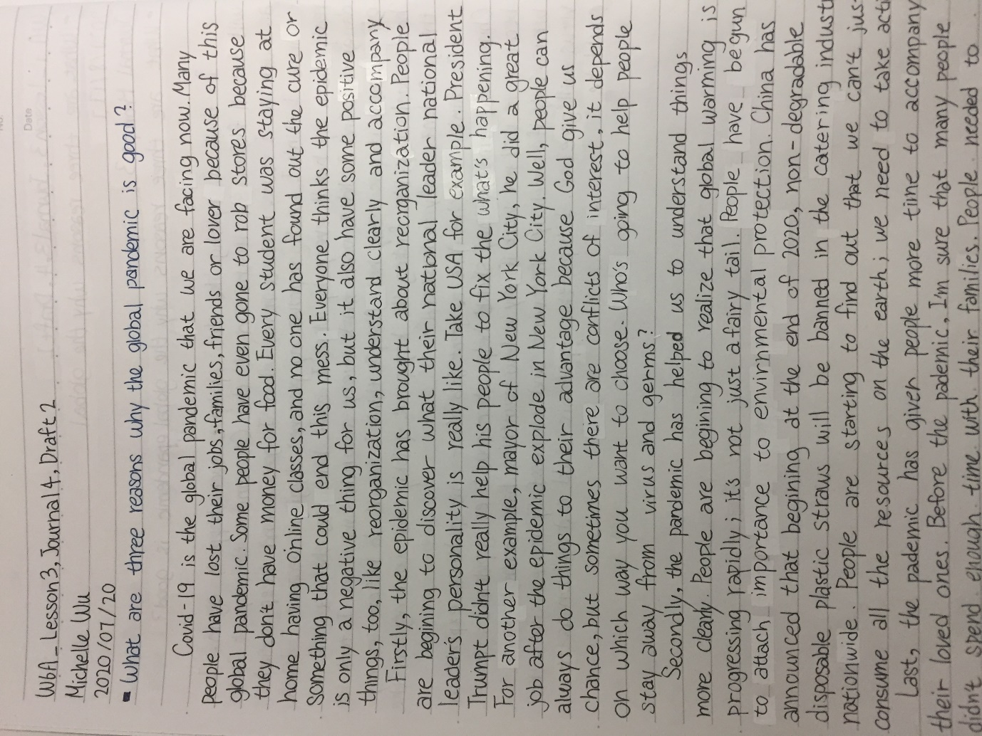

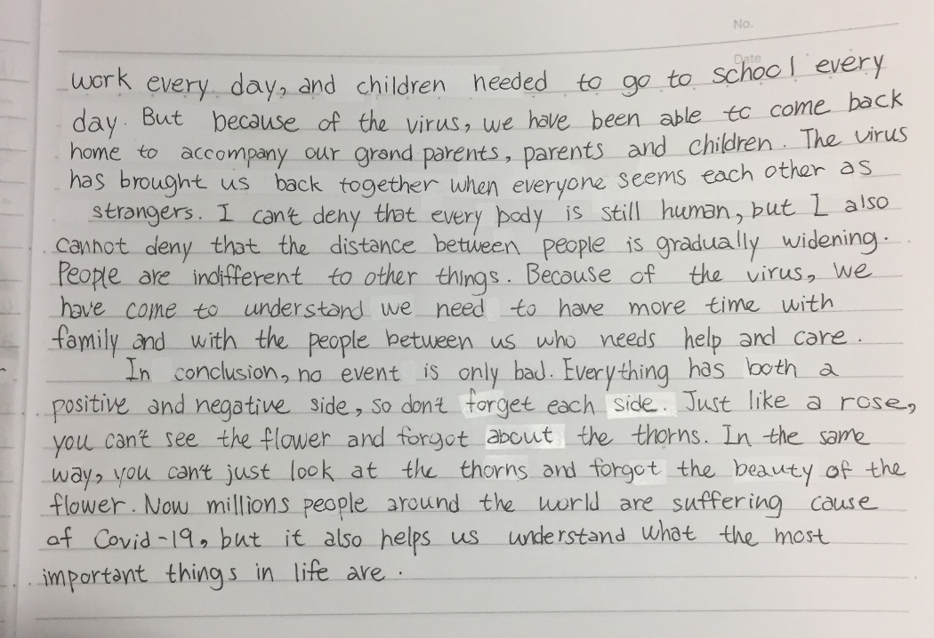

[Journal 5: Write a 200-300 word summary of the article using at least three direct quotes.: Draft 1]

Summary of “A lovely bunch of coconuts and all that”

This report is about how precious and nutritious coconut is, and it talked about some short story that have to do with coconut. Frist, the report began with an event of an allegations of misuse of Thai monkeys to coconut and other harvest fruits. The people who did this things profess that he didn’t “abuse” those monkey. He said that the monkey was hurt is because he doesn’t familiar to training monkey. He start to talk about the experience of visited to the South, and he said the coconut was very hard to took, only the monkey can climb up the tree and get it. The second story was talked about a person’s recall, when he was young, coconut was the same as banana, full of the fairly exacted; and people love coconut even made a lovely song for it. He love knocked coconut off its perch hardly, but he didn’t realize there are so much coconut had been dialed down when he knocked coconut off its perch. The third story is talking about people used to crazy about the coconut song, and decided to play it every time when Cambridge United Football Club win. The fourth story is talking about a one crew have a lot of coconut on the boat when they have a disaster on the boat and lose connection to the lifeboat, and they survived because coconut is rich in nutrients and water. The last story is talking about how high the coconut was in Thailand and PC times. This article tells us more about coconut, and let us understand more about how precious coconut is.

[Journal 5: Write a 200-300 word summary of the article using at least three direct quotes.: Draft 2]

[Journal 6: Write your opinion of the situation. Do you agree or disagree? Why?: Draft 1]

Opinion to the report of “A lovely bunch of coconuts and all that”

I think the report is good, but I couldn’t really catch the point of it; I didn’t understand what actually does the author trying to tell us; but I think the point of the report is telling us how precious and how nutritious coconut is. I agree to the author, coconut is valuable, because it’s hard to get and nutritious, but I never really knew how to open it without let the water flow out. I think coconut is a good fruit whatever it’s hot or cold. I think the author of this article cited a lot of short stories was trying to let us discover all the things about coconut our self in these stories. Although I don't understand the structure of this article very well, I find the little story in this article interesting

[Journal 6: Write your opinion of the situation. Do you agree or disagree? Why?: Draft 2]

[Journal 7: What character traits are most important to you? Why?: Draft 1]

The most important character traits is I can everybody’s personality quickly even they didn’t acted it out. The first reason of I think this is my most important personality is I don’t usually provoke others, because I always carefully avoiding anger of others, so I have good relationship with many people. The second reason is that I always know what other people like and don't like, so that I know what to do to others to achieve what purpose, but I never use unscrupulous divisive tactics or to reach my destination with an unfaithful friendship, I always have faithful friendship. The last reason is I know exactly how to improve my relationship with other people and improve it in a way that is acceptable to both sides; I also know how to destroy the relationship with others, but I never did that. I think this character traits is very important to me, so I can easily have good relationship; and of course I have this character trait is also because I have experienced a lot of things and have seen a lot of things happen and end to know how to improve my emotional intelligence.

[Journal 7: What character traits are most important to you? Why?: Draft 2]

[Journal 8: Why do some people struggle to do the right thing?: Draft 1]

So many people struggle to do the right thing, and why? I think one of the reason is most of the people were not “struggle” to do the right thing, is something might force them not letting them to do the right thing, like, bully. Many school have bully between the students, even teacher. Why did no one come forward to help those who were excluded, were bullied? Because people afraid to be bully too, they don’t want to stop other from bully others, they afraid they will be bully by them too. Another reason is some people are selfish, they only do something that will help them; they think do the right thing wouldn’t help them to get anything. Well, some people struggle to do the right thing is because they think do right thing is not fun, they like to see people suffered, or sad, but I don't think there's a lot of people do this kind of thing. There still a lot of people on the world are doing right thing every day, so let’s not just look at negative side.

[Journal 8: Why do some people struggle to do the right thing?: Draft 2]

[Journal 9: What does it mean to have integrity?: Draft 1]

I think there is nothing on the world is perfect. If people called somebody is integrity, that’s mean he/she is more integrity than normal people, that doesn’t mean he is totally integrity on anything. People always think they love integrity people, but the truth is not what they think; because integrity people seek for righteous, but sometime right thing doesn’t always have right ending. Like, some single mom have no more money to raise her own kids, but she still want to keep her own children beside her; but the most of the time that court will take the children away from their mother, and put them in the orphanage. It’s the right thing, but it’s not humanization. The meaning of have integrity is to have the quality of honest, and full of righteous. –

[Journal 9: What does it mean to have integrity?: Draft 2]

[Journal 10: What is the hardest lesson you’ve ever had to learn? Why?: Draft 1]

I think the hardest lesson I’ve ever had to learn is get rid of everything you are addictive. It’s hard, and people could get rid of these thing by them self. Like some people are addictive to movies, they watch movie every day, every minuet, every second, at breakfast, at work, at lunch, at dinner, at shower, before bed. Some people are addictive on work, work every day, even break, even family meeting, even with friends, even went they already tired. Bible said everything that you are addictive is awful. You can have you favorite thing to do, but if it already became addictive, it’s bad.

[Journal 10: What is the hardest lesson you’ve ever had to learn? Why?: Draft 2]

[Journal 11: What is your favorite way to show your individuality? Why? Draft 1]

I’m kind of listener, I always listen to everybody, some people complain about their parent to me, and some people narrate about people around them to me. Some people asked me about what choice should they make. People trust me and told me their troubles, I listen and give them my advice. I think I’m a good listener to people around me; but my advice is always rational, so I won’t stand at your side is because you are my friend, but usually I told people politely, and most of the time I still stand at my friend’s side. So I could said that I’m a good listener, because I could help my friends and give what they need.

[Journal 11: What is your favorite way to show your individuality? Why?: Draft 2]

[Journal 12: If you could take home any animal from the zoo as a pet, which would you choose?: Draft 1]

I will take raccoon back home, because they are cute!!! First time I saw raccoon is last year Christmas in Australia, my family travel to Australia to visited my sister who was studied in Sydney. I saw three raccoon in the zoo, and they are so cute!!! I couldn’t put my sight away from them. I know that raccoon is very smart and very tricky, it has flexible body and it can walk with two feet, they love finding food in garbage; but they still so cute! They love” washing food” to find the shape of food. They love water too, they love taking bath and swimming. If I could take home any animal from the zoo, I will take raccoon home, definitely.

[Journal 12: If you could take home any animal from the zoo as a pet, which would you choose?: Draft 2]

[Journal 13: What is your favorite way to show your individuality?: Draft 1]

I think the most important part of being a good friend is telling truth. Many people might think it’s not a good action to tell their friends what they do is right or wrong, but I say that only there is a people who really listen to what your suggest is the friend that you should make. When we are talking to our friends, we shouldn’t talking like making commandment, we should make sure we are really saying these things just for their goods. I think it’s really important to be honest and make friend sincere, others definitely know who are really be sincere and honest to them.

[Journal 13: What is your favorite way to show your individuality?: Draft 2]

[Journal 14: Who is your hero? What inspires you about this person?: Draft 1]

There are many people can be my hero, but I will only tell one. I’m a Christian, I know God is my hero because when I get to a lot of sadness and loneliness, he was always there be with me. He didn’t talk to me, but I know he used things to let me know what he is trying to tell me. He give me a lot of things even I never asked to him or anybody. He always be with me whatever I been through. I know he love me isn’t because what talent I have, he love me because he made me, so I know he is my hero.

[Journal 14: Who is your hero? What inspires you about this person?: Draft 2]